

**UNIVERSITY INSTITUTE OF ENGINEERING**

**Department of Computer Science & Engineering**

**Subject Name:** Competitive Coding

**Subject Code:** 20CSP-314

**Submitted to: Submitted by:**

Er. Mamta Punia Name: Sahil Kaundal

UID: 21BCS8197

Section: 616

Group: A

**INDEX**

|  |  |  |  |  |  |  |
| --- | --- | --- | --- | --- | --- | --- |
| **Ex. No** | **List of Experiments** | **Conduct (MM: 12)** | **Viva**  **(MM: 10)** | **Record (MM: 8)** | **Total**  **(MM: 30)** | **Remarks/Signature** |
| 1 | To demonstrate the concept of Array. |  |  |  |  |  |
| 2 | To demonstrate the concept of Stack and Queue. |  |  |  |  |  |
| 3 | To demonstrate the concept of Linked List. |  |  |  |  |  |
| 4 | Sorting and Searching: Implement the concept of Searching and Sorting techniques. |  |  |  |  |  |
| 5 | To implement the concept of Graphs. |  |  |  |  |  |
| 6. | To demonstrate the concept of Tree Data Structure |  |  |  |  |  |
| 7. | To Demonstrate the concept of String Data Structure |  |  |  |  |  |
| 8. | Dynamic Programming |  |  |  |  |  |
| 9. | Backtracking |  |  |  |  |  |
|  |  |  |  |  |  |  |

**Experiment 9.1**

**Student Name:** Sahil Kaundal **UID:** 21BCS8197

**Branch:** BE CSE (Lateral Entry) **Section/Group:** 616/A

**Semester:** 5th **Date of Performance:** 10/11/2022

**Subject Name:** CC Lab **Subject Code:** 20CSP-314

1. **Aim/Overview of the practical:**

Backtracking

You have an N * M chessboard on which some squares are blocked out. In how many ways can you place one or more queens on the board, such that, no two queens attack each other? Two queens attack each other, if one can reach the other by moving horizontally, vertically, or diagonally without passing over any blocked square. At most one queen can be placed on a square. A queen cannot be placed on a blocked square.

<https://www.hackerrank.com/challenges/queens-on-board/problem>

1. **Apparatus / Simulator Used:**

* Windows 7 or above
* Google Chrome

1. **Objective:**
   * To understand the concept of Backtracking.

**4. Code:**

#include <vector>

#include <string>

#include <algorithm>

#include <iostream>

#include <unordered_map>

#include <cassert>

using namespace std;

struct Solution2

{

    typedef basic_string<unsigned char> __Board;

    typedef __Board::value_type         __Row;

    long long solve(const vector<string> & B){

        if (B.empty() || B[0].empty())

            return 0;

        for (size_t i = 0; i < B.size(); ++i){

            __Row row = 0;

            for (size_t j = 0; j < B[i].size(); ++j){

                if ('.' == B[i][j])

                    row |= (1 << j);

            }

            row = ~row;

            board.push_back(row);

            __Board p;

            genPlacements(row, p, B[i].size());

            placements.push_back(p);

        }

        bmask = (1 << B[0].size()) - 1;

        return help(0, 0, 0, 0);

    }

private:

    static void genPlacements(__Row block, __Board & ret, int M){

        for (int i = 0; i < M; ++i){

            __Row p1 = 1 << i;

            if (0 != (p1 & block))

                continue;

            ret.push_back(p1);

            for (int j = i + 2; j < M; ++j){

                __Row p2 = p1 | (1 << j);

                if (0 != (p2 & block))

                    continue;

                __Row m2 = (1 << j) - (1 << (i + 1));

                if (0 == (m2 & block))

                    continue;

                ret.push_back(p2);

                for (int k = j + 2; k < M; ++k){

                    __Row p3 = p2 | (1 << k);

                    if (0 != (p3 & block))

                        continue;

                    __Row m3 = (1 << k) - (1 << (j + 1));

                    if (0 == (m3 & block))

                        continue;   //there is not enough blocks between 3 Qs

                    ret.push_back(p3);

                }

            }

        }

    }

    __Row calcMask(__Row mask, __Row blocks){

        __Row b = mask & blocks;

        mask &= ~b;

        return (mask & bmask);

    }

    static int hash(size_t row, __Row lmask, __Row dmask, __Row rmask){

        int r = row;

        r <<= 8;

        r += lmask;

        r <<= 8;

        r += dmask;

        r <<= 8;

        r += rmask;

        return r;

    }

    long long help(size_t row, __Row lmask, __Row dmask, __Row rmask){

        if (row >= board.size())

            return 0;

        const int h = hash(row, lmask, dmask, rmask);

        unordered_map<int, long long>::const_iterator wh = save.find(h);

        if (wh != save.end())

            return wh->second;

        const __Row blocks = board[row];

        const __Row mask = lmask | dmask | rmask | blocks;

        long long ret = 0;

        lmask = calcMask(lmask, blocks);

        dmask = calcMask(dmask, blocks);

        rmask = calcMask(rmask, blocks);

        if (__Row(-1) != mask){

            const __Board & ps = placements[row];

            for (size_t i = 0; i < ps.size(); ++i){

                const __Row p = ps[i];

                if (0 != (mask & p))

                    continue;

                ++ret;

                ret += help(row + 1, (lmask | p) << 1, dmask | p, (rmask | p) >> 1);

            }

        }

        ret += help(row + 1, lmask << 1, dmask, rmask >> 1);

        return (save[h] = ret % 1000000007);

    }

    __Board board;

    vector<__Board> placements;

    unordered_map<int, long long> save;

    __Row bmask;

};

typedef Solution2 Solution;

int main()

{

    int t;

    cin >> t;

    while (t--){

        int n, m;

        cin >> n >> m;

        vector<string> b;

        for (int i = 0; i < n; ++i){

            string line;

            cin >> line;

            b.push_back(line);

        }

        cout << Solution().solve(b) << endl;

    }

    return 0;

}

**5. Result/Output/Writing Summary:**

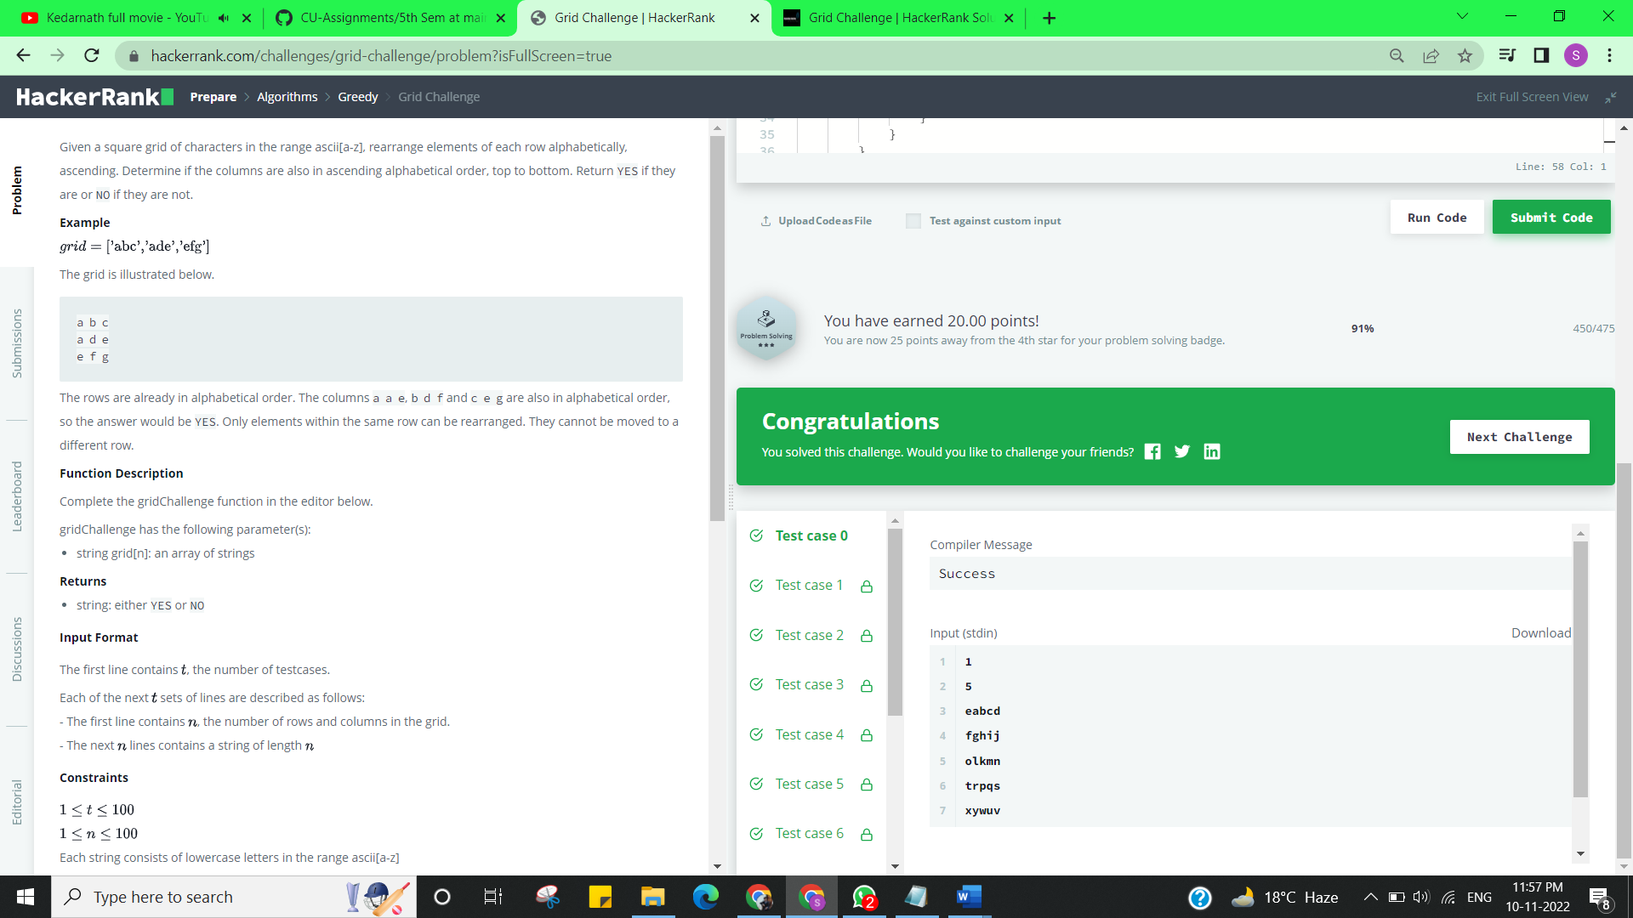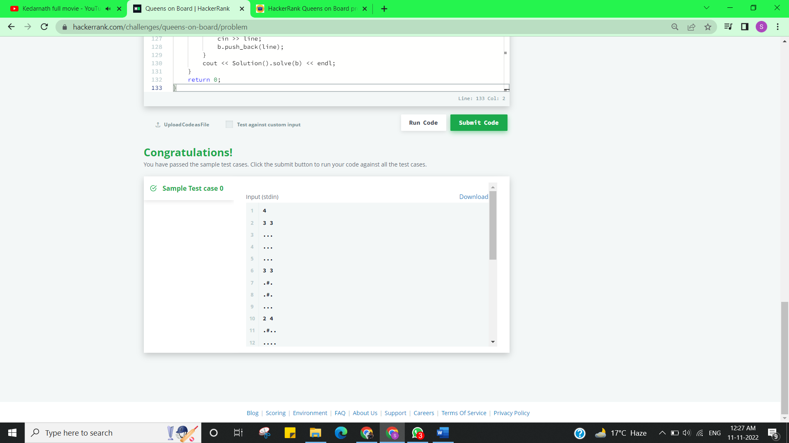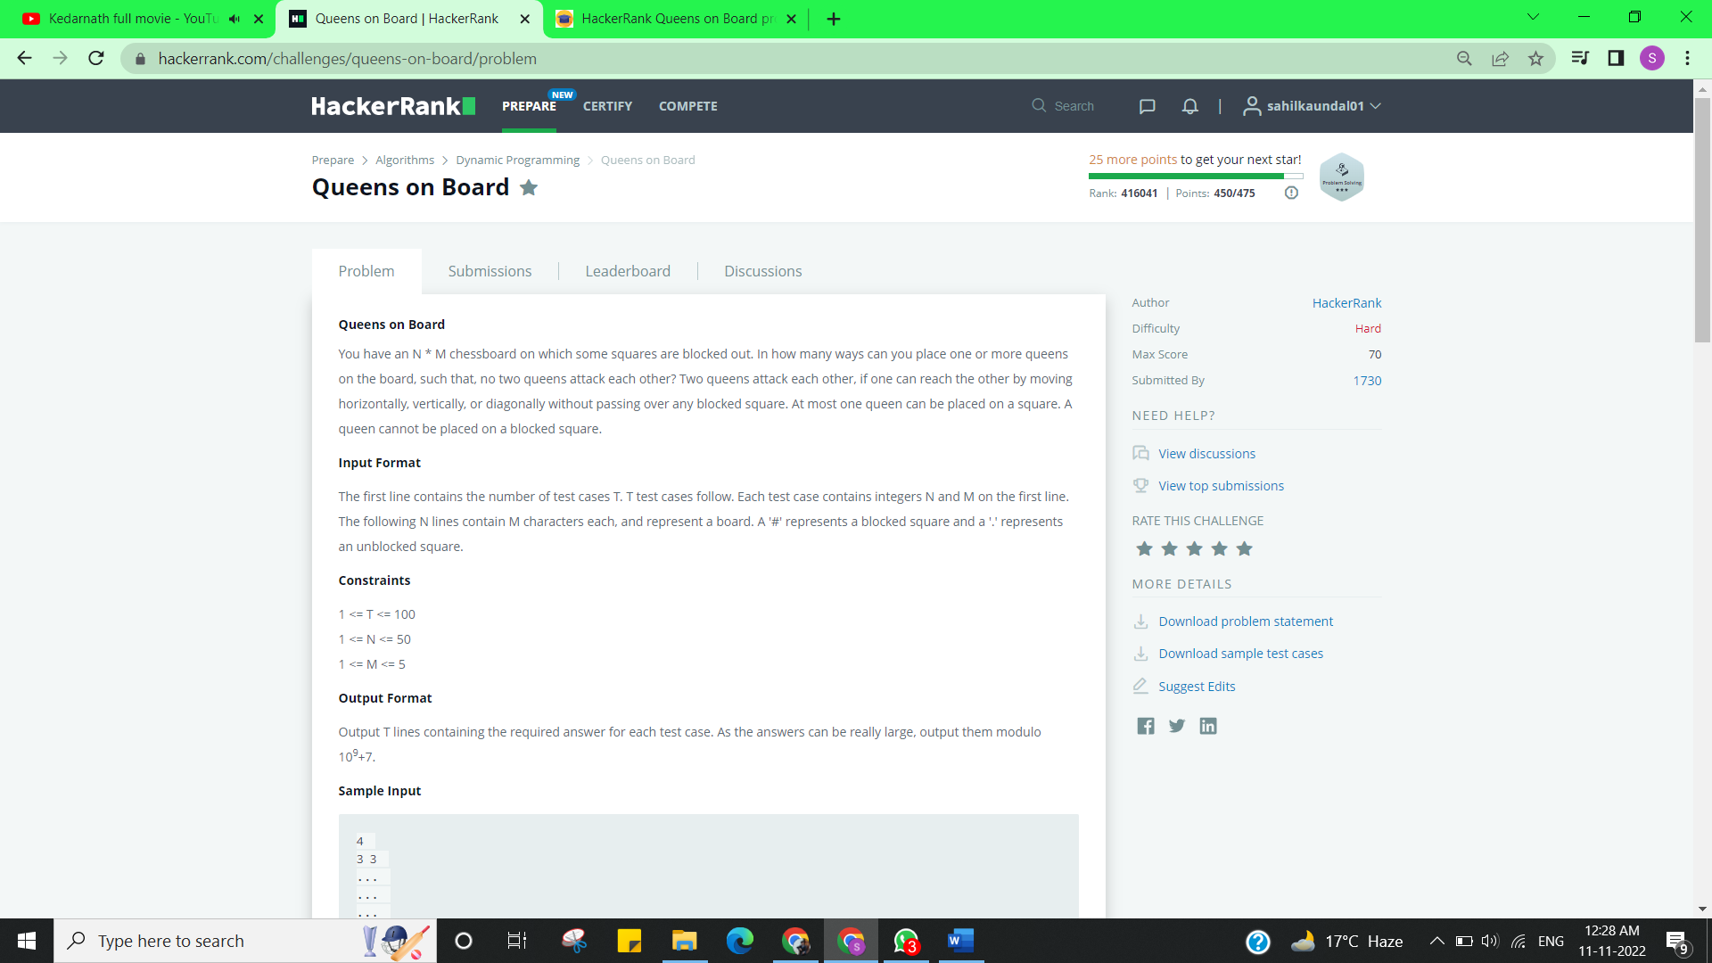

**Experiment 9.2**

1. **Aim/Overview of the practical:**

Backtracking

You are given a list of N positive integers, A = {a[1], a[2], ..., a[N]} and another integer S. You have to find whether there exists a non-empty subset of A whose sum is greater than or equal to S.

You have to print the size of minimal subset whose sum is greater than or equal to S. If there exists no such subset then print -1 instead.

<https://www.hackerrank.com/challenges/subset-sum/problem>

1. **Apparatus / Simulator Used:**

* Windows 7 or above
* Google Chrome

1. **Objective:**
   * To understand the concept of Backtracking.
2. **Code:**

import java.util.Scanner

import scala.collection.Searching._

object Solution {

  def main(args: Array[String]): Unit = {

    val sc = new Scanner(System.in)

    sc.nextLine

    val a = sc.nextLine.split(' ').map(_.toLong).sortBy(-_)

    var sum = 0L

    val sums = a.map(v => {

      sum += v

      sum

    })

    val t = sc.nextInt

    (0 until t).foreach(_ => {

      val s = sc.nextLong

      val count = (sums.search(s) match {

        case InsertionPoint(i) => i

        case Found(i) => i

      }) + 1

      println(if (count <= a.length) count else -1)

    })

  }

}

1. **Result/Output/Writing Summary:** 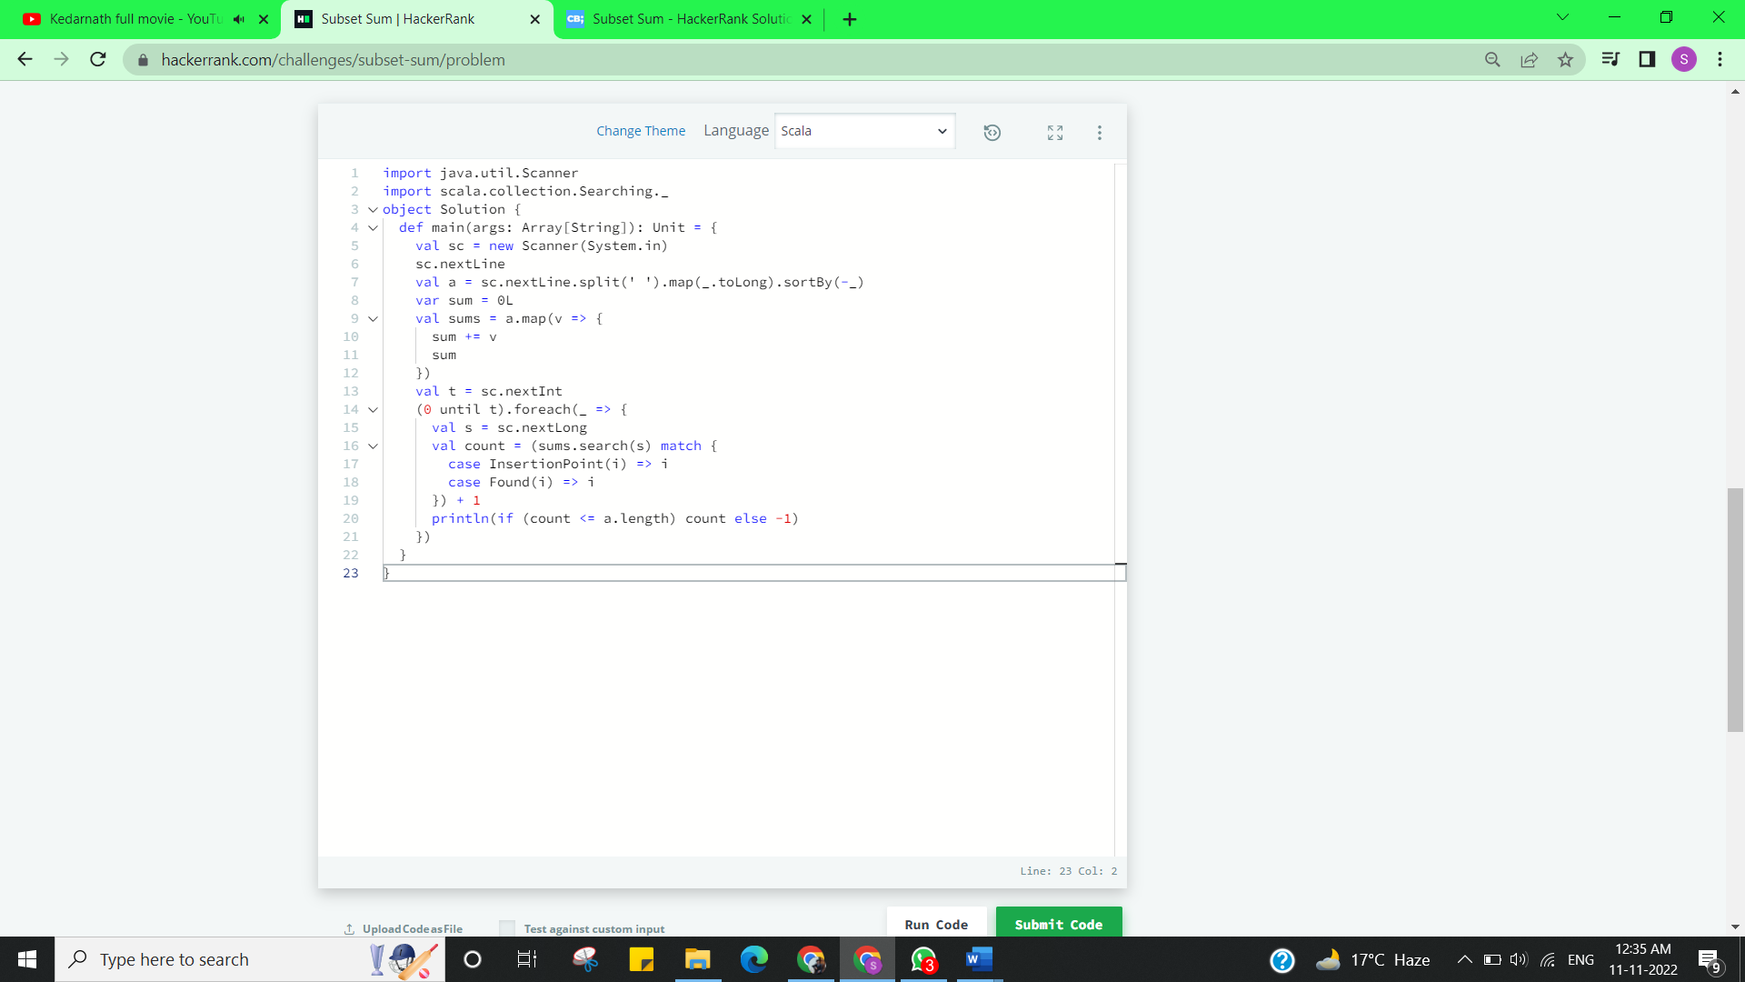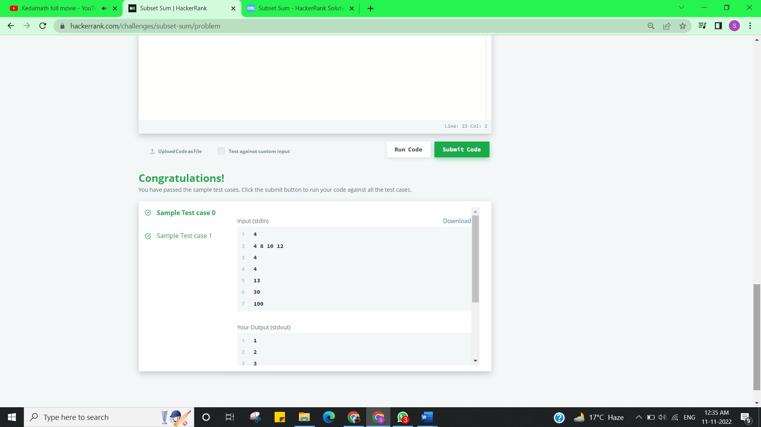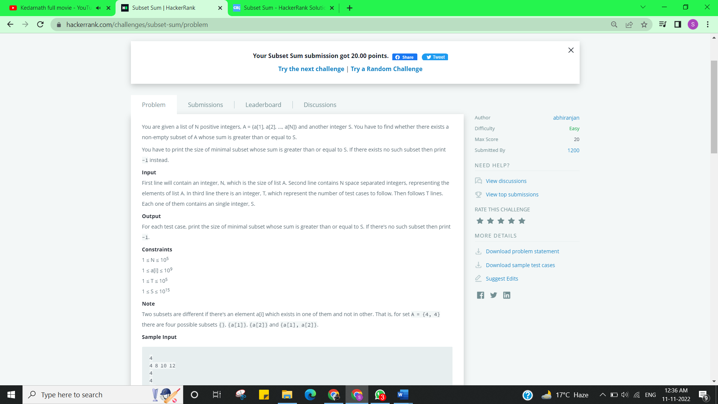

**Learning outcomes (What I have learnt):**

* + Learned the concept of Backtracking.

**Evaluation Grid (To be created as per the SOP and Assessment guidelines by the faculty):**

|  |  |  |  |
| --- | --- | --- | --- |
| Sr. No. | Parameters | Marks Obtained | Maximum Marks |
| 1. |  |  |  |
| 2. |  |  |  |
| 3. |  |  |  |
|  |  |  |  |